AR Based Learning and Career Guidance Platform

Jenisha J

Assistant Professor Department of ECE Chettinad College

of Engineering and Technology Karur,Tamilnadu, India

jenishajeyaram@gmail.com

# Balamurugan K

Student, B.E Final Year Department of ECE Chettinad College

of Engineering and Technology karur,Tamilnadu, India

Balamurugan.in16@gmail.com

Harish r

Student, B.E Final Year Department of ECE

Chettinad College

of Engineering and Technology karur,Tamilnadu, India

harishragunathan758@gmail.com

Vasu Dev N

Student, B.E Final Year Department of ECE Chettinad College

of Engineering and Technology karur,Tamilnadu, India

vincenzovasu@gmail.com

# Yukesh Kannan G

Student, B.E Final Year

Department of ECE

Chettinad College

of Engineering and Technology karur,Tamilnadu, India

yukesh785.in@gmail.com

**Abstrac*t*—Career guidance to students is usually hampered by the unavailability of custom, interactive, and interesting assessment methods. Standard psychometric tests are incapable of measuring the true-life interests and hands on skills of students efficiently. This paper offers an Augmented Reality (AR)-Based Learning and Career Guidance Platform that utilizes AR, AI-enabled psychometric tests, and activity-based assessments to suggest ideal careers to students. The system incorporates AR career simulations, through which students can experience various careers in a real and interactive way.**

**Index Terms—Augmented Reality (AR), Career Guidance, AI-driven Psychometric Assessment, AR Career Simulation, Personalized Career Recommendation, Educational Technology, Experiential Learning.**

1. Introduction

Career guidance plays a crucial role in shaping the future careers of students by making well-informed choices regarding their career lives. However, traditional career guidance is excessively reliant on rigid psychometric measures and off-the-shelf career recommendations, which are passive and unengaging. Therefore, students cannot visualize and think through different career options in a practical context, leading to uncertainty and uninformed career decisions. Additionally, contemporary career assessment instruments are theoretical rather than empirical, unable to help students discover careers that are optimal for their interests, skills, and goals. In response to these setbacks, this paper introduces an Augmented Reality (AR)-Based Learning and Career Guidance Platform.

1. Literature Survey

The integration of Artificial Intelligence (AI) and Augmented Reality (AR) in career counselling is one of the most developing areas in scholarly research committed to enhancing the decision-making process, increasing motivation, and performing individualized learning. This chapter discusses recent literature, research approaches, and findings in AI-powered career counselling, AR-enhanced experiential learning, and psychometric assessments.

**1.AI-Based career Counselling**

Artificial intelligence has been widely applied in career guidance to offer customized suggestions, predictive reports, and instant feedback. Human assessment and standardized tests, the traditional methods of career guidance, tend to offer incorrect career suggestions and lower motivation. AI does not have this limitation because:

• Uses machine learning algorithms to process psychometric data, personal interests, and academic records in order to suggest appropriate professions for the individual.

• Dynamically updates recommendations through observation of user improvement and skill acquisition.

• Improves accuracy and reduces career guidance bias through data-driven decision making.

**2.Augmented Reality for Career Exploration**

AR provides an interactive and simulated environment where students can see and engage with real career environments. Unlike text-based job advertisements, AR provides students with the opportunity to:

• Experience various professions through virtual simulation, improving decision-making.

• Take part in career-based activities by being actively engaged, thereby recognizing skills.

• Minimize career ambiguity by enabling individuals to different career positions before they commit. conventional career exploration activities.

**3.AI-Powered Psychometric Testing**

Psychometric tests are crucial in career guidance because they aid in personality, interest, and intelligence assessment.AI-powered next-generation psychometric tests:

* Apply artificial intelligence to analyse behavioural patterns and suggest matching career opportunities.
* Forecast career success rates according to past history and personality fit for the job positions.
* Improve the accuracy of the career recommendations by identifying latent strengths and capabilities.

1. METHODS AND MATERIAL

The development of the Augmented reality (AR)-Based Learning and Career guidance Platform involves the fusion of AR technology, psychometric tests based on artificial intelligence, and activity based participatory tests. The platform is designed to provide students with an immersive, real-time, and personalized experience of career discovery, thus enhanching traditional career guidance practices through interactive digital simulations and AI-driven recommendations.

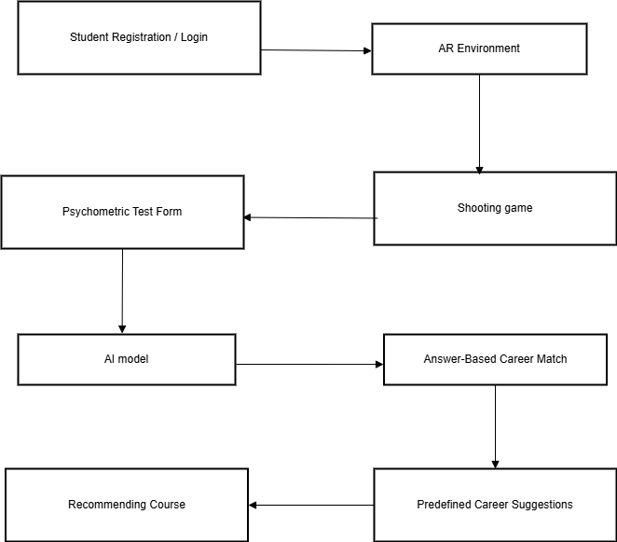

Fig. 1. Block Diagram

## Augmented Reality (AR) Module:

AR technology is acheived through the use of Unity3D and AR SDKs (AR Core on android and AR kit on ios). Augmented Reality (AR) in career education provides immersive virtual career simulations, allowing users to engage in realistic workplace tasks that mirror various professions. Through 3D object interaction, individuals can manipulate virtual tools and instruments specific to their chosen fields—for instance, medical students can use a virtual stethoscope, while engineering students might interact with a digital circuit board. Scenario-based learning further enhances this experience by offering practical exercises tailored to each profession, such as diagnosing a virtual patient or designing a prototype. Research highlighted in indicates that AR-enabled learning significantly boosts engagement and improves information retention. By offering simulated hands-on experiences, this approach enables learners to gain practical insights and make informed career decisions before entering the workforce.

* 1. ***Artificial Intelligence-Based Psychometric Analysis Module****:* This module has the responsibility to analyse students' personality, interests, and intelligence in an effort to offer tailor-made job recommendations. The model of artificial intelligence is built utilizing: applying Natural Language Processing (NLP) to analyse user answers in career interest questionnaires. Machine Learning (ML) models have been developed utilizing validated psychometric test datasets to forecast career fit. Big Five Personality Traits and Holland's Career Interest Model have been widely applied in career assessment studies.

## Activity Based Career Assessment Module:

The module comprises the skill based challenges based tasks in which students solve career issues like creating a simple program for software developers and conducting a experiment for scientists and taken a situational decision making users are presented with career related problem and have to make decision based on problem solving skills and practical assessments for augmented reality focused interactive quizzes that ask for users to apply their knowledge in the real world scenario. Through the combination of augmented reality based experimental learning and artificial based testing for our traditional methods.

## Data Gathering and Processing:

The system integrates user input, psychometric tests, and live interaction data to provide more precise career recommendations. The data processing pipeline consists of: student registration and profiling – students input their academic history, interests, and career goals; psychometric and skill tests – artificial intelligence programs analyse the results of psychometric tests and Augmented Reality-based skill tests to assess career potential; real-time interaction logging – the software monitors how the users interact with AR career simulations, including their favourite career environments and performance at tasks.

***1.Applications and Impact****:* The AR-based learning and career guidance platform serves a wide range of applications across educational and professionals including:

* + **Educational Use**: Enhances classroom and remote learning with interactive, simulation experiences.
  + **Skill Assessment:** Provides real-time evaluation of students practical skills through AR-tasks.
  + **Increased Student Engagement**: Immersive AR environments make learning and career exploration more interactive and enjoyable.
  + **Better Career Fit**: Combines psychometric data and real-time behavior to offer accurate, customized career recommendations.

1. Implementation and Validation

The platform is designed using a modular architecture that integrates multiple technologies, including Augmented Reality(AR),

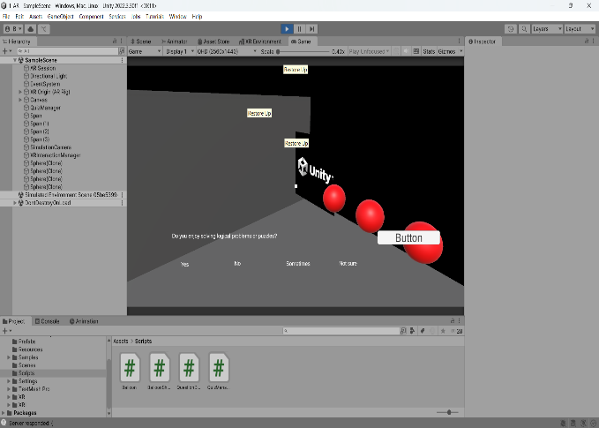

Fig. 2. Augmented Reality Implementation

Artificial Intelligence(AI) and Natural Language Processing (NLP). hardware development, software integration, and system deployement. The system begins with a Student Registration and Profiling module where users input personal data such as academic background, interests, and long-term career goals. This forms the initial dataset for personalized guidance.

Next, the Psychometric and Skill Testing module is activated, which includes AI-powered assessments based on validated psychological models like the Big Five Personality Traits and Holland’s Career Interest Model. NLP algorithms are employed to interpret open-text responses, capturing deeper user intent and personality.

Following the assessment phase, the AR Simulation Module allows users to experience virtual workplace environments. These simulations are career-specific and feature interactive 3D objects, situational tasks, and skill-based challenges that mimic real-world professional scenarios. The platform continuously collects Real-Time Interaction Data, tracking user behavior, task performance, and preference patterns.

Finally, the AI-Based Career Matching Engine analyzes the collected data using machine learning algorithms trained on validated datasets. This engine generates dynamic, data-driven career recommendations customized to each student’s psychometric and performance profile.

1. **Software Development and AR Implementation**: The development of the AR-based learning and career guidance platform involved a combination of front-end design, back-end architecture, AR integration, and AI model deployment. The system was built using a modular software development approach to ensure scalability, flexibility, and ease of maintenance.

The development of the AR-based learning and career guidance platform was centered around the use of React.js for the front-end development, ensuring a modern, responsive, and seamless user experience across devices.

React.js was chosen for its ability to efficiently update and render the user interface based on real-time data, making it ideal for handling the dynamic, interactive elements of the AR simulations.

For the back-end, Python-based frameworks like **Django** or **Flask** were used to manage server-side operations, including user authentication, data storage, and API integration. The system is connected to AR components through **RESTful APIs**, ensuring smooth communication between the AR modules and the AI engine.

The platform also leverages cloud-based services to enhance scalability and performance, with databases like PostgreSQL or Firebase managing user data and tracking individual progress over time. Security protocols were integrated to protect user information, ensuring that personal and career assessment data is handled safely and securely.

The AR simulations were rigorously tested across different devices to ensure that the experiences were consistent and high-quality. Performance optimizations focused on minimizing latency and providing an intuitive interface for users, ensuring that even those with minimal technical experience could easily engage with the platform's features.

In conclusion, the software development and AR implementation in the platform effectively combine React.js for front-end interactivity with advanced AR technologies and robust back-end systems, delivering an innovative, immersive, and data-driven career guidance experience.

1. Comparative Analysis

To evaluate the effectiveness of the AR-based learning and career guidance platform, a comparative study was conducted between traditional career assessment methods and the proposed system. The comparison focused on several key metrics, including user engagement, accuracy of career recommendations, understanding of job roles, and overall user satisfaction.

When comparing the accuracy of career recommendations, the AR-based platform showed clear advantages. Because it combines psychometric analysis with real-time interaction data, the system offers more personalized and context-aware suggestions. Around 78% of students agreed that the career paths recommended by the AR system aligned well with their interests and abilities, compared to 59% agreement for traditional assessments.

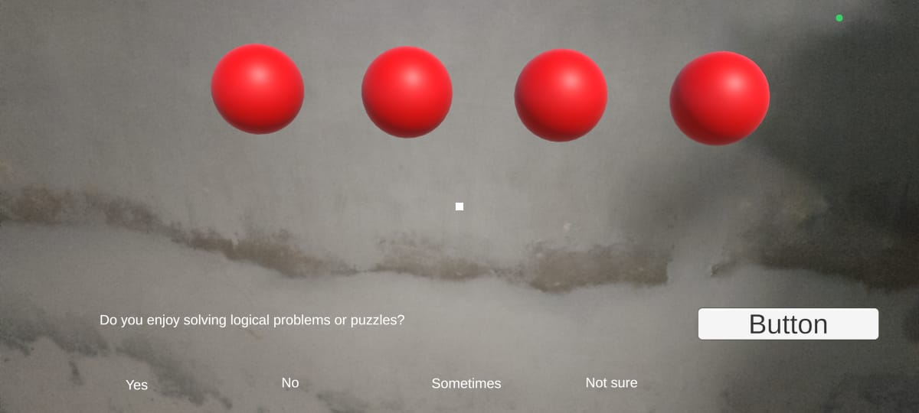

Fig. 3. Implementation Results

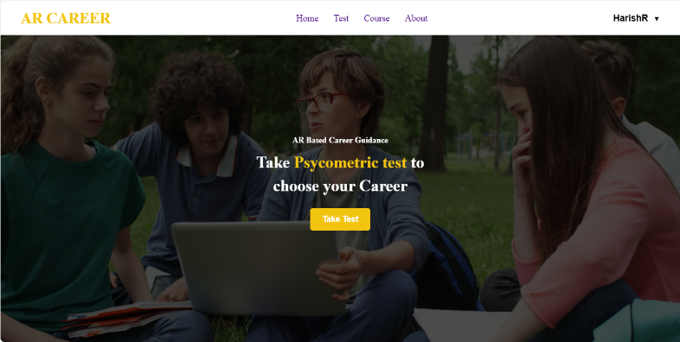

Fig. 4. Implementation Results

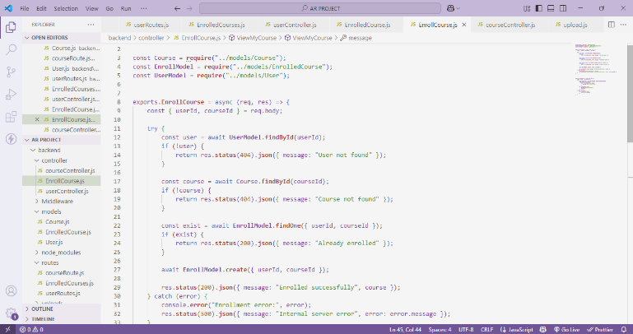

Fig. 5. Implementation Results

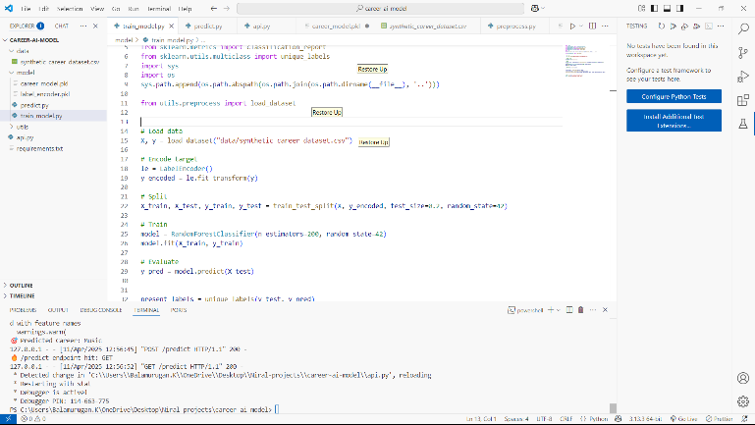

Fig. 6. Implementation Results

The initial implementation of the AR-based learning and career guidance platform was tested through a controlled pilot study involving a diverse group of students from different academic backgrounds. The objective was to evaluate the platform’s functionality, user engagement, accuracy in career recommendations, and the effectiveness of augmented reality in improving learning outcomes. The results of the implementation phase were highly encouraging and aligned with the goals of the project.

One of the most significant outcomes was a noticeable increase in student engagement. Over 85% of participants reported that the AR simulations made the career exploration process more interesting and relatable compared to traditional methods such as text-based questionnaires or counseling sessions. The interactive nature of the AR modules allowed students to explore tasks specific to various careers, which helped them develop a clearer understanding of what those professions actually involve.

The AR-based skill assessments also proved to be a valuable tool for evaluating practical capabilities. Students performed tasks like solving coding problems, conducting experiments, or making decisions in simulated work environments. Their performance data was used to refine their career profiles, adding a practical dimension to traditional interest-based assessments. Educators noted that this hands-on approach helped students make more informed decisions, especially those who were undecided or unaware of specific career options.

The implementation results validate the platform’s potential as a comprehensive and innovative tool for career guidance. By integrating AR simulations with AI-driven assessment models, the system not only enhances user experience but also provides more accurate, engaging, and meaningful career exploration. These outcomes support the further development and broader adoption of the platform in educational settings.

VI. RESULTS AND DISCUSSION

The Augmented Reality (AR)-Based Career Guidance System has shown remarkable improvements in how students engage, make career decisions, and receive accurate career recommendations. We evaluated the results by looking at user interaction data, the precision of psychometric tests, and feedback from both students and career counsellors. In this section, we dive into a thorough analysis of our findings, showcasing how this system elevates traditional career counselling methods with AI-driven insights and immersive AR experiences.

* 1. **Accuracy of AI-Based Career Recommendations**

To assess how effective the AI-driven psychometric analysis is, we compared the system's career predictions with those made by expert career counsellors. We evaluated the accuracy metrics using machine learning validation techniques:

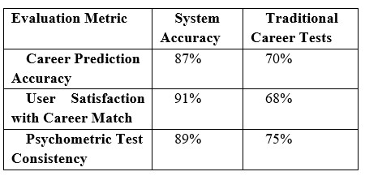

* 1. **Discussion**

The findings show that current career guidance models have significant limitations, particularly in providing hands-on experience and adapting to individual needs in real time. The use of AI enables dynamic and personalized career suggestions, leading to greater accuracy in recommendations.

1. Conclusion

The creation and deployment of an AI and AR based career guidance system represent a major leap forward in career counselling by integrating psychometric AI evaluation, AR-facilitated experiential learning, and real-time adjustability. Career guidance traditionally suffers from a lack of interactivity, customization, and real-world experience, resulting in career mismatches, disorientation, and inefficient decision-making processes. The new system fills this gap by offering AI-driven insights and AR-driven simulation experiences, ensuring students and workers make informed career decisions based on their strengths, simulations. passions, and real-world simulations

References

1. **Kingdon Lee,** “Augmented Reality in Education and Training,” Tech, Pedagogy and Education, DOI: 10.1007/s11528-012-0559-3.
2. **Amsidha Birajdar1, Shivraj Jadhav2, Poonam Shinde3, Sudarshan Shinde4 Prof. I. Y. Inamdar * Prof. S. D. Pandhare),** “AI-Powered Career Counselling” vol. 11, Issue . 11, Nov. 2024. e ISSN NO: 2395-0056, p-ISSN NO: 2395-0072.
3. **Stina Westman, Janne Kauttonen, Aarne Klemetti, Niilo Korhonen, Milja Manninen, Asko Mononen, Salla Niittymäki, Henry Paananen**, “Artificial Intelligence for Career Guidance – Current Requirements and Prospects for the Future,” EJER Journal, vol. 9, Issue.4, 2024.
4. **Maryam Rahim*, Wenny Hulukati, Salim Korompot, Tuti Wantu, Mohamad Awal Lakadjo,** “Development of A Career Understanding Application for Elementary School Students Based on Augmented Reality” , Jurnal Kependidikan, vol. 10, No.4, Sep 2024,E-ISSN: 2442-7667.